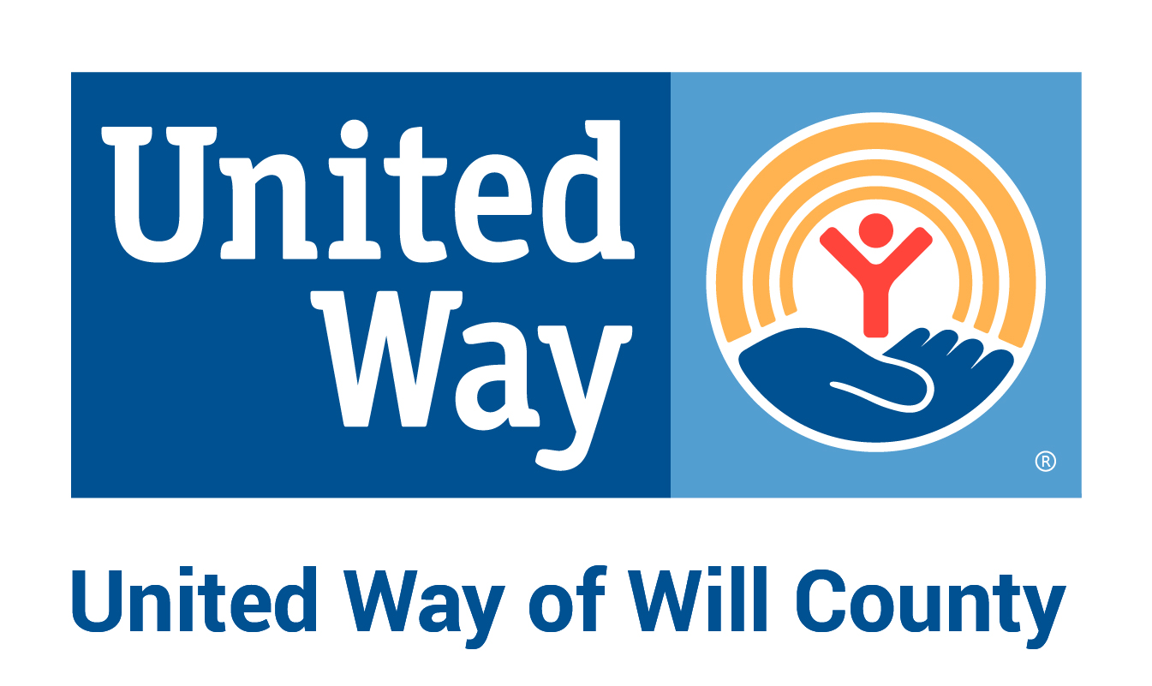

Creative Sparks

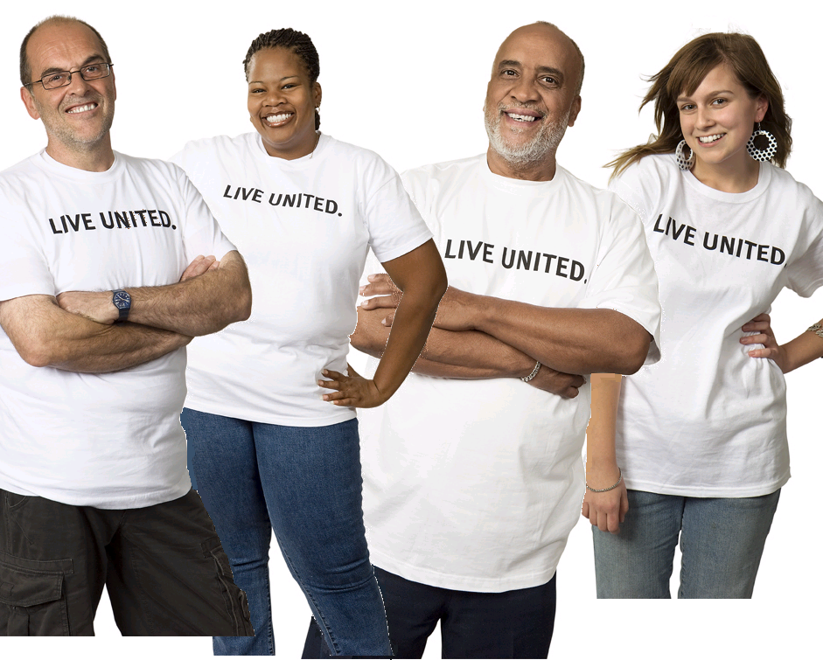

A resource for creative fundraising ideas


54 North Ottawa St. Suite 300
Joliet, IL 60432
www.uwwill.org

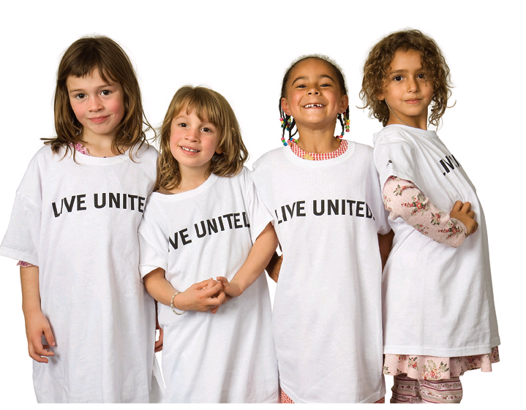
A fun campaign makes your job more enjoyable and creates increased awareness of United Way Will County among your co-workers. With that in mind, here are some creative sparks—examples of ideas and events—to help ignite an exciting and effective employee campaign. Included are simple campaign promotions, as well as unique, successful special events that companies have sponsored in the past. Remember that not everything you do has to make money. Sometimes just getting together for fun and team-building can be a good way to remind people about the campaign. Use this booklet as a starting point to help develop ideas tailored to your company’s theme. Many companies also like to include fun activities in their kickoff or as a thank you to their employees for contributing to a great campaign.

Ways to get the word out…

 
- email/intranet messages
- company intranet postings
- articles and ads in employee newsletter
- payroll stuffers
- calendar of campaign events
- posters/fliers/banners: elevators, stair wells, inside of restroom stall doors, cafeteria, water cooler, break area, coffee machine
- door hangers on office doorknobs
- announcements at staff meetings
- table tents
- piece of candy or event-related item with a reminder tied to it
- voicemail messages

Apple Pie Bake-Off
Find out which employee can
make the best apple pie. Hold a competition in which employees can put their best family recipes to the test. On the day of the event, sell taste tickets and have employees vote on the best apple pie maker in the company. Award a prize for the winner.

Baby Picture Contest
Employees bring in a baby
picture of themselves and
staff guesses who is who.
Charge an entry fee for
employees to submit their guesses. The person with the most correct answers wins a prize.

Balloon Pop
Employees donate prizes for this event—a variation of a traditional raffle. Before filling a balloon with helium, put a note inside with the name of a prize. Employees pay $1 to buy a balloon and pop it to find out what prize they’ve won. Include a United Way fact in each balloon.

Event Planning Tips


- name a special event chair and ask him or her to create a special event team to share the duties and spread the enthusiasm

- decide if the goal of the event is to raise awareness, boost employee morale, raise money or all three

- put together a budget

- choose an event that’s a good match for your work environment and employees

- select a date that doesn’t conflict with other company events

- reserve an easily accessible location and get approvals that you need to conduct the event

- assign responsibilities to team members(publicity/promotions, prizes, food, decorations, volunteer recruitment, etc.)

- inform your United Way representative of your special event(s) and ask for any help and/or advice you may need

- schedule a run-through a day or two before the event

- after the event, evaluate its success, make notes for next year’s committee and report the results to employees and your United Way representative

- send thank-you notes to everyone who helped make the event a success, including volunteers and vendors who donated food and prizes

1
event planning tips
3

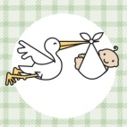

Old Fashioned Carnival

Invite employees to an old-fashioned carnival, complete with cakewalks, bake sale, bubble blowing and 50-cent hotdogs. Have a hula-hoop contest and hoop-shoot to give it that “flashback” flavor. Charge participants a fee to enter contests. Have a dunk tank with your favorite executives. Charge $2 for three balls. Have a pie-throwing booth with all your favorite executives behind the “eight ball.”

Casual Day
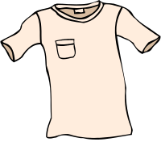
Sell Casual Day badges entitling the employee to dress casually on a pre-determined day. Badges can be purchased for a nominal fee. Define in your organization what is meant by “casual” to avoid confusion. In some organizations it may mean “business casual,” which does not include jeans, sandals, etc. Monitor who is entitled to be dressed casually so that the employees' donations truly entitle them to a privilege that those not buying badges do not have. You may want to post a flier explaining the casual dress day to visitors.

Children’s Drawing Contest

Employees are given “official photographs” of one or two top executives to take home for their children to draw. Contest is limited to children under 12 who are related to any employee in the organization. Employees can vote for the best drawing by paying a nominal fee. Prizes will be given to all participants (try getting a local fast food restaurant to donate a certificate for a free lunch). Count all votes and announce the winners at the campaign's final event. A variation of the contest would be to have children draw a picture relating to a theme creating greater awareness of United Way.

Basket Auction
Ask each department at your organization to sponsor, create and fill a theme basket (spa day, chocolate, golf, cooking).The baskets are then auctioned off. This event has been very successful at several companies and is a great way for folks to show off their creativity and caring.


Be A Hero With Roses
Purchase long-stemmed roses to sell on Sweetest Day. Talk to a flower wholesaler for better rates.

Book Sale
Invite employees to donate books. Encourage them to bring their donations in early. Price paperbacks at $1 and hardbacks at $2.The leftover books can be donated to United Way agencies.

Candy Fundraiser

Purchase your employees’ favorite candies to sell or contact a local company. Place candy in a prominent area where employees will be tempted to satisfy their sweet tooth.

Themes

Classy Brown Bag Lunch
Charge a small fee for attendance at a series of brown bag lunch classes where attendees have the opportunity to learn a new skill (flower arranging, pottery painting), relieve some stress (yoga, time management) or improve their health (heart healthy cooking). Ask an area teacher or trainer to donate his or her time and/or ask your United Way representative to tap the resources of an expert from one of our partner agencies.

Company Olympics
Teams participate in Olympic events, such as wastebasket paper ball free throws, balance a Styrofoam cup on a serving tray while navigating an obstacle course, make a paper airplane and fly it the longest distance,
make the longest paper
clip chain in one minute or
staple, fold, and stuff letters
into envelopes in one
minute. Teams pay to
participate, and the company
buys prizes or lunch for the
winning team.

Compliment-O-Gram
Make up special forms and sell them to office employees as a way to give a compliment to a fellow employee. Charge $1 per compliment or $2 if they wish to do so anonymously.

- Be a Superhero
- Building a Brighter Future
- Caring Works Magic
- Doing Good Today for Great Tomorrows
- Give…Wholeheartedly
- Giving is Good News
- I Give at the Office
- Imagine What We Can Do…Together
- Join the Winning Team
- Let’s Make the Difference
- Make a Change for the Better
- Make Your Caring Count
- Neighbors Helping Neighbors
- Paint a Brighter Tomorrow
- Rise to the Challenge
- Take Stock in Our Community
- Tune in to Your Community
- You’re a Lifesaver Every Day
- We’re Counting on You
- Write a Happy Ending
- Working Wonders Together

Use any of the following starting
points to create a theme:
- a movie (Mission Possible)
- a tv show (Happy Days for United Way, Make Caring a Reality)
- sports (Pitch In and Give, Teaming Up For Better Tomorrows, Shoot for the Stars)
- summer or fall holiday (Fourth of July, Oktoberfest, Halloween, Labor Day)
- the 1950s, 1960s, 1970s or 1980s




OR

Quick Picks

- CEO dunk tank
- used book/CD/video/DVD sale
- rummage sale (set guidelines of what will and won’t be accepted, i.e., must be in working order, no clothing, etc.)
- partner agency fair (ask your United Way representative to help schedule)
- plant or flower sale
- charge a small “late meeting fee”
- taste of [your company]
- dress down day with a specific theme (orange and brown, the 80s, etc.) 
- executive shoe shine
- pancake breakfast or ice cream social (served by the management team)
- dress up day
- treasure hunt (sell clues to a mystery location)
- 50/50 raffle
- casual day for United Way (sell casual day stickers for employees to wear for a fee)
- craft and bake sale
- make-your-own sundaes
- clean computer screens & keyboards (for a fee)
- raffles
- sell sweets for Sweetest Day
- candy bar or popcorn sale
- flea market with used office furniture, computers, etc.

Employee Funniest Videos
Employees submit videos of their craziest moments. Participants donate a nominal fee to watch the videos. Observers choose their favorite video.

Creative Tie Contest
Divide up into different teams within the office. Each team should use its creative talent to “design” a tie. Put the ties on display for a few days or for the duration of the campaign. Put a container with each tie to collect money for the best tie. The tie with the most money wins. Designate someone within the company to model the winning tie and wear it for the entire day wherever he or she goes.

eBingo (electronic bingo)
Sell Bingo cards for a small fee. Send emails sporadically throughout the week with one or two Bingo numbers each time. The first person to get Bingo should let everyone know by sending an email to all users, and, of course, she or he will win a donated prize.

Employee Cookbook
Collect recipes from employees. Then retype your collection and group it into sections. Sell the cookbook for a nominal fee. Consider having an employee's child provide the cover artwork. Books can be printed and bound by a local business. See if you can get this service done pro bono. This event has been so popular that some organizations have not been able to fill all requests. Plan for an enthusiastic response!

Executive Receptionist
Put together a board with head shot pictures of company executives. Place an envelope below each picture for “votes.”The executive who receives the
most contributions of money in their envelope wins the honor of being “receptionist for the day.”As the time period, you may see large contributions being made to ensure a certain executive wins!

Got Games?

Educate employees about United Way and its partner agencies in a fun way by incorporating a game show theme. Use information from your ECC Guide or provided by your Resource Development Manager. Play the game(s) at a group meeting or give everyone the opportunity to play by creating a worksheet or posting questions online.
A few ideas…

• Jeopardy: Have 10 “answers” about United Way; have employees write down the corresponding “questions.” OR used United Way’s PowerPoint version!

• The Price is Right: Employees guess
how much of a United Way contribution
could be used for a specific service or
program ($1, $5 or $10 a week).

Let’s Make a Deal: Go around the office and ask random United Way-related questions (“Name two agencies that help older people,” “Which United Way partner agency is closest to
our office?”). Each time someone gets the answer right, give him or her a prize on the spot. Ask your CEO to go with you and hand out the prizes.

Halloween Pumpkin
Carving Contest

How about a Halloween theme for your campaign this year? Have a pumpkin-carving contest. Charge a nominal fee to enter and vote. Award prizes in categories including best traditional pumpkin, most creative pumpkin, best effort by group or individual and best entry involving multiple pumpkins.

Hats Off to United Way
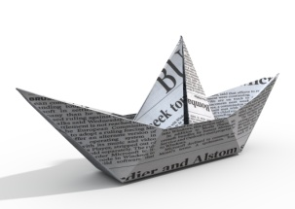
Designate a day as “Hat Day” and ask employees to wear their favorite hat to work. Award prizes for silliest hat, biggest hat, hat that most represents your company, etc.

Human Sundae
Place pictures of managers on jars in the company lobby. Employees can vote with their change for their favorite manager to be made into a human sundae. The winning manager is given a rain poncho and a shower cap and members of their department cover him or her with ice cream, chocolate sauce, etc.

Good sports (and contests)

Las Vegas Day
Convert your office or
cafeteria into a Las
Vegas Casino for the day.
Conduct casino card, dice and wheel games. Provide food and drinks to sell during the event.

Miniature Golf
Create a two-hole course in a conference room area to test the skills of your employees. The lowest score (which may be decided by
a tiebreaker) will take home a tacky sports coat. Interested employees return an entry form, pay a nominal fee and bring a putter the day of the event. A variation of this event would be to create a tiny golf course in the parking lot of your organization and use child-sized golf clubs.

Mini Indy 500
Rent or borrow remote-controlled cars and set up an
“Indy 500” race.
Use office
supplies to
make the
track more
interesting.
Teams can be sponsored to compete. Spectators can place bets on their favorite team or car.

A Night at the Races
Obtain a video of real live horse racing. Set up booths to take bets on horse numbers. Solicit prize donations from local merchants. Offer food and refreshments and charge a donation fee to attend the event.

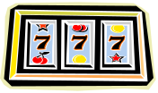

- lunchtime spaghetti or chili cook-off
- office scavenger hunt
- spelling bee
- pie-eating contest
- video/computer game competition
- tricycle race
- croquet tournament on nearby lawn
- elevator races
- Halloween costume or celebrity
look-alike contest
- hooping it up basketball competition
- fun run or walkathon
- “how many jelly beans in the jar?” or another counting contest
- softball game
- pet matching game ($1 to enter; raffle off a prize to those with the most correct answers)
- quiz show (use company and
United Way factoids)
- hallway bowling or putt-putt
(with child-size clubs)

Jail and Bail Day
Designate an area to represent the jail or if you have a talented maintenance department have them construct one. Charge people to put someone in jail and also charge to get them out. Designate certain employees to be the “deputies” to take employees to jail. Make use of the time employees are in the jail by having them fold the
United Way pledge forms for
distribution to help with
attaching them to
employee paychecks.



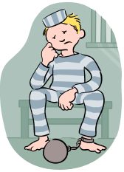

Outrageous Day
Employees who pledge a pre-determined amount get to dress as outrageously as they want (costumes). Invite employees to come to work dressed as their favorite United Way agency. This works well as a wrap-up event, if the
campaign is over near Halloween. At one company, an employee dressed as a loaf of bread to represent a food pantry, another as a telephone to represent a crisis hotline and others came as day-care kids and Girl Scouts.
.
Penny Wars
Divide into teams, obtain large jars (ask area water cooler companies for a donation; they usually have lots of jars that are intact but are no longer watertight), and have the teams decorate them. Put pennies in your jar to increase the score and sabotage others by adding silver coins, which decrease the score.

Silent Auction
Ask vendors to donate items, ask employees to donate handmade items, solicit gift certificates from local restaurants, etc. Put the items on display in a prominent area of the company. At a designated time, close the bidding. Then let employees know of the highest bid and continue the auction with one hour left to outbid it to win.

Stand Tall for United Way
For a donation, receive your height in raffle tickets. Everyone receives a minimum amount of tickets, but the taller you are, the better your chance of winning. Split the pot with United Way and the raffle winner.

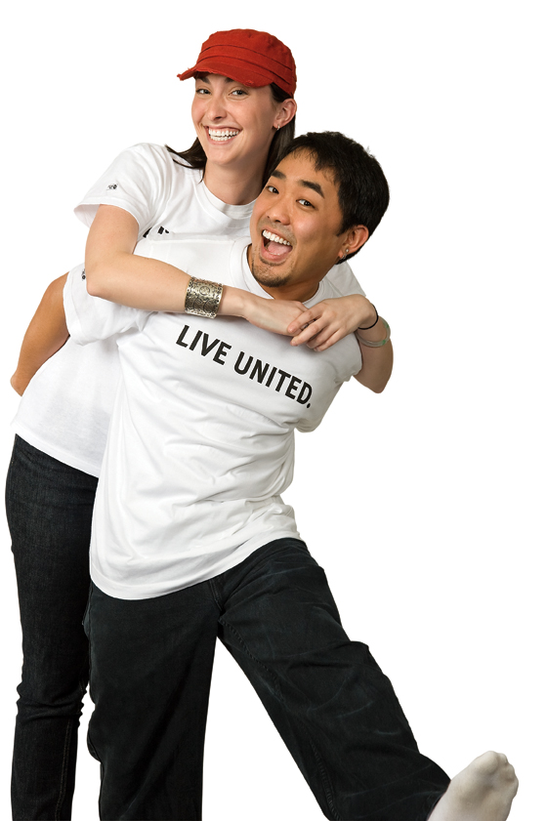

8

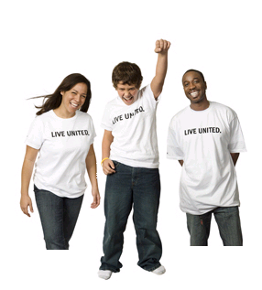
Take a Day Off for United Way
Employees “buy” a vacation day. When employees choose to participate, their wages from the day’s work are deducted from their paycheck. The organization may choose to match the amount deducted, with all proceeds donated to the campaign. This is a win-win situation: the organization achieves high participation, the employees get a vacation day and the community is helped.

Talent Show
Use your campaign theme to put on an employee talent show. Charge employees admission to the show.
Sell popcorn for a snack as employees enjoy the show.

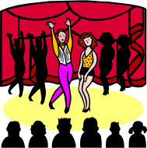

Ticket Giveaways
Free tickets for movies, theater productions, amusement centers and other local attractions can be a pledge incentive. Encourage employees to pledge $2 per week by giving two movie passes to every employee who meets that challenge.

Trash or Treasure Raffle
Ask employees to bring in a wrapped white elephant item...an unwanted, still usable (although not necessarily useful) object from their home. All who donate can get a raffle ticket, and when their name is called, they can choose one of the mystery items. Don’t forget to publicize the winners and their new treasures.

Summer Get-A-Way Picnic
Host a summer picnic with a grilled
lunch for employees. Raise money by
conducting raffles and including
games for prizes, e.g., an egg
relay, tricycle races, water
balloon toss and tug-of-war.
Obtain prizes from vendors and
local companies.
.
.
Tailgate Party
Consider creating a sports theme for your
campaign since the United Way campaign
period coincides with the football season. Sell football fare from a truck in the parking lot “tailgate” style. Offer hot dogs, popcorn, peanuts, soft drinks and other goodies. Organize a tag football game, with participants donating an entry fee and observers wagering on the outcome.
.





Incentives and Prizes
Turkey Giveaway
Use the Thanksgiving holiday as an inspiration for special events. Raffle off a turkey for Thanksgiving dinner.
Purchase a turkey or ask
employees to donate their
free turkey(s) earned
from shopping at local
grocery stores.
.

Ugly Lamp Month
Use any white elephant (an ugly lamp works great) and offer the opportunity to purchase points to move the item to someone's workspace or to keep it out of your work area. Calculate and move daily, weekly, etc. Wherever it ends up at the end of the time period, it must stay for one month or until the next campaign.

Ugly Tie or Ugly Earring Contest
All contestants pay a nominal fee to enter the best awful earrings or ugly ties they own (or borrow). Choose a day that the voting will take place. Place voting boxes at various places around the office and charge $1 per vote. Have a parade for all contestants, offering a last chance to vote at the end of the day. Circulate the names of entrants the day before the event so employees can anticipate the voting. Take photos for use in the organization's newsletter.
.
Valet Parking
Have management park employee cars and retrieve them at the end of the day. Prizes can be awarded for giving levels.
0
.

- bonus vacation days
- gift certificates donated by local merchants
- golf lessons
- mugs, t-shirts, key chains, etc., with company logo
- one share of company stock
- movie passes or lottery tickets
- sleep-in-late or leave-work-early certificates
- traveling trophy for department with highest participation or percentage increase
- casual days
- job swap (boss does winner’s job for a day)
- flowers every month for a year
- department pizza party
- candy
- prime parking spaces or free parking
- day off to volunteer
- chair or hand massage
- cafeteria coupons
- homemade craft or cooking donated by employees
- buttons/pins
- lunch or dinner with CEO
- gift baskets or goodie bags
- early dismissal on a Friday
- employee-designed t-shirts
- a trip (using company frequent-flyer miles)
- open pop machine if company reaches goal or spend pop machine profit on a catered breakfast or lunch

WWW.UNITEDWAYSTORE.COM
Your link to official United Way branded campaign products, gifts, and incentives.



EDUCATIONAL IDEAS

- Create awareness of your campaign with posters and signs

- United Way fact-filled screen savers

- Share employee testimonials – Stories from employees who have volunteered or have been helped by a UW agency

- Arrange presentations with UW representatives

- Insert UW success stories or UW impact statistics in payroll (Share your payday with United Way – add a mini payday candy bar!)

- Provide information on how a donor’s donation can impact the community. Use payroll inserts or internet blast

- Lunch and learn.

- Lunchroom Table Tents with UW facts

CONTEST IDEAS

- Campaign Slogan/Theme/Poster Contest
- Game Shows – Jeopardy, Wheel of Fortune, Who wants to be a Millionaire
- “Big Hair” Contest
- Paper airplane contest
- Puppy Love – Which owner most resembles their pet
- Guess the number of jelly beans, rubber bands etc
- Ugly hat/sport coat day
- Chocolate chip cookie sale. Employees all bring their favorite chocolate chip cookies to sell

LOW BUDGET CAMPAIGN IDEAS
- Chili Cook-off during lunch. Employees bring their best chili in a crock pot for a chance to win the most votes
- Lunch box auction. Employees bring in lunches to be auctioned off. Prizes for the most creative, nutritious, elegant or humorous
- Office Treasure Hunt
- Softball or volleyball tournament
- Flea market with employee donated items
- Ugly sweater contest
- Name that employee from baby pictures
- Oldest company T-shirt or oldest “favorite band” T- shirt
- Hat day contest
- Paint/sketch a portrait of a co-worker contest
- United Way word scramble/crossword timed contest

SPECIAL EVENT FUNDRAISERS

- Silent Auction with employee/company donated items
- Employee craft sale
- Potluck lunch
- In-house telethon to call for employee pledges
- Popcorn sale
- Raffle of donated prizes/gift certificates
- Car wash while you work – Management washes your car
- Bake sale with recipes
- Shoe shining
- Plant or flower sale
- Jeans day , casual day, team jersey day
- Balloon Pop – Donated prizes are put in filled helium balloons. Employees can receive a chance to pop a balloon to claim their prize
- Services donated by employees as fundraiser: pet sitting, car wash, drop off dry cleaning etc.

LOW BUDGET CAMPAIGN IDEAS
CEO/COMPANY LEADERSHIP IDEAS

- Golf with CEO
- Breakfast or lunch with CEO and 3 friends
- Mass voicemail, email from CEO
- Wine and Cheese party with leadership
- Free parking, premier parking or use of executive parking space
- Executive for a day
- Ask each of the executive team to donate a prize for an auction
- Have top management serve coffee, ice cream or lunch to employees at a United Way meeting

CAMPAIGN THEMES
- Mardi Gras – wear purple, green and gold
- Beach party
- Decades 50s, 60s, 70s, 80s
- Movie themes
- Academy Awards theme – wear your best dressed attire, maybe a tux or an evening gown. Bring “business attire” to whole new level!
- Hawaiian Luau – wear Hawaiian shirts, floral prints, grass skirts if you’ve got them!
- Sports – wear your favorite sports team apparel
- Picnic
THANK YOU IDEAS

- Prizes for turning in pledges early
- Drawing for 1st time givers
- Early dismissal for increasing pledge to a specified level
- Executives serve lunch to employees
- Extra day off for 10% pledge increase
- Free lunch/pop in company cafeteria
- Campaign committee walks the floor to say thank you and pass out treats
- Build your own sundae party
- Hot chocolate & whipped cream break on a cold day
- Handwritten notes from the campaign committee
- Pizza party
- Mass voicemail/email from CEO and/or campaign leadership
- UW agency and UW reps attend lunch breaks to thank employees
- Run a thank you ad in employee newsletter/publications
- Attach a note to a lifesaver “Thanks for being a lifesaver for United Way!”
- Attach a note to pack of Extra gum, “Thanks for going the “Extra” mile for United Way!”

